**CHAPTER 4**

**METHODOLOGY**

4.1 Introduction

4.2 System Flow Chart

4.3 Algorithm

**4.1 Introduction**

The purpose of this **system SMART ATTENDANCE SYSTEM USING FACE RECOGNITION SYSTEM (Out-house Project)** for **MASTERS SOLUTION** is to build an attendance system which is based on face recognition techniques. Here face of an individual will be considered for marking attendance.

During each session, Faces will be detected from live streaming video or webcam. The faces detected will be compared with Images present in the dataset/folder. If match is found, attendance will be marked for the respective student. At the end of each session, list of present students will be marked and their name will be

Inserted in the excel sheet on real-time basis.

Traditional method of attendance marking a tedious task in many schools and colleges. It is also an Extra burden to the faculties who shown attendance by manual while calling the names of students Which might take about 5 minutes of entire session, face recognition is as important as biometric.

**4.2Flow Chart**

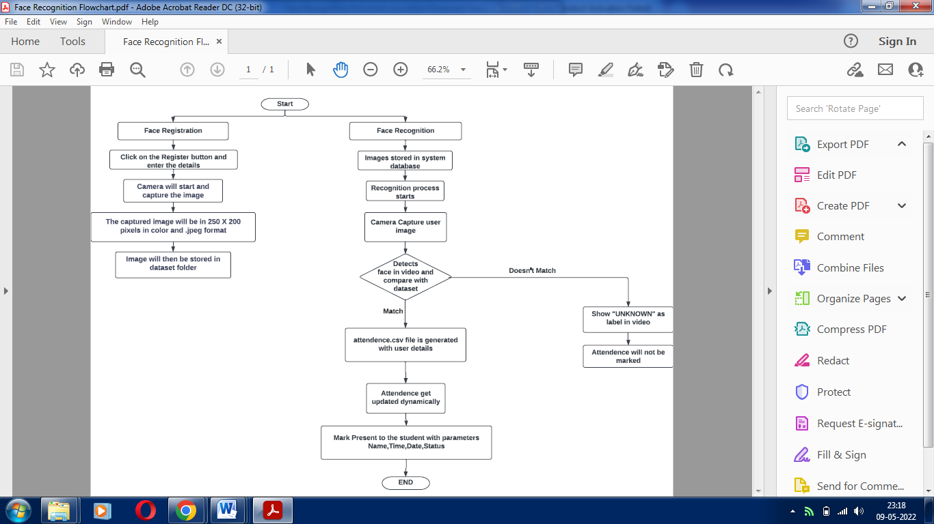

**4.3 Algorithms**

**Face Registration**

Step 1: Start

Step 2: If New User then Click on the Register Button and enter the details

Step 3: Capture will start and capture the image

Step 4: The captured will be in 250 x 250 pixels in colour and in .jpeg format

Step 5: Images then will be stored in the dataset folder

**Face Recognition**

Step 1: Start

Step 2: Images stored in system database

Step 3: From here Recognition process starts

Step 4: The Camera will pop-up and capture the user image

Step 5: Detects face in video and compare with the images stored in dataset

1. If match

* Attendance .csv file is generated with user details
* Attendance will get updated dynamically
* Mark Present to the student with parameters Name,Time,Date,Status

1. If Doesn’t match

* Show “UNKNOWN FACES” as label in video
* Attendance will not be marked.

Step 6: End